
Name: Anwesha Madavi PRN: 25070122043 Subject: Programming with Java
Batch: 2025-2029

ASSIGNMENT II
TITLE: Develop a Java application demonstrating the use of default, parameterized, and copy constructors for object initialization and data management.

Assignment 2: Methods and Static Members

Problem Statement:
Develop a Java application demonstrating the use of default, parameterized, and copy constructors for object initialization and data management.

Learning Objectives:
To understand and implement default, parameterized, and copy constructors for object initialization.

Theory:
Constructors are special member functions that are automatically invoked when an object is created.
Java supports default constructors provided by the compiler, parameterized constructors for initializing objects with user-defined values, and copy constructors (implemented manually) for creating duplicate objects. Constructors improve code readability and simplify object initialization while supporting object-oriented programming principles.

Source Code:
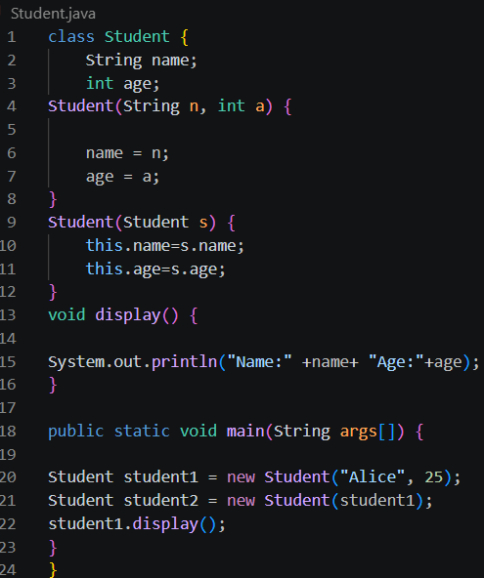

Program Outcome:


Conclusion:
Object Initialization Mastery: Successfully implemented the three primary pillars of object creation in Java: default, parameterized, and copy constructors.
Role & Functionality: * Default ensures safe, fallback initial states.
- Parameterized offers direct, flexible data binding at creation.
- Copy constructors safely clone objects without risking shared reference bugs.
- OOP Impact: Mastered these techniques to reinforce robust Object-Oriented Programming (OOP) design patterns, producing highly readable, scalable, and maintainable code.

